Date:
PRACTICAL-1
Aim: Create a static web page which defines all text formatting tags of HTML in tabular format
Code:
<html>
<head>
<h2>Text Formatting Tags</h2>
<title>
My first Table
</title>
<body>
<table border="1">

<th>HTML Tag</th> <th> Output</th>

<tr><td>normal Text</td> <td> hello world</td> </tr>
<tr><td>Font & its attributes</td> <td> <h3>hello world</h3></td> </tr>
<tr><td>&lt B &gt </td> <td> <B>BOLD</td> </tr>
<tr><td>&lt I &gt</td> <td> <i>ITALIC</tr>
<tr><td>&lt U &gt</td> <td> <U>Underline</td> </tr>
<tr><td>&lt EM &gt</td> <td> <EM>Emphasis</td> </tr>
<tr><td>&lt STRONG &gt</td> <td> <STRONG>Strong</STRONG></td> </tr>
<tr><td>&lt TELETYPE &gt</td> <td> <TELETYPE>Teletype</td> </tr>
<tr><td>&lt CITE &gt</td> <td> <CITE>Cite</CITE></td> </tr>
<tr><td>&lt STRIKE &gt</td> <td> <STRIKE>Strike</td> </tr>
<tr><td>&lt BIG &gt</td> <td> <BIG>Big</td> </tr>
<tr><td>&lt SMALL &gt</td> <td> <SMALL>Small</td> </tr>
<tr><td>&lt SUB &gt</td> <td>a <SUB>b</td> </tr>
<tr><td>&lt SUP &gt</td> <td> a<SUP>b</SUP></td> </tr>

</table>
</body>
</html>

Output:

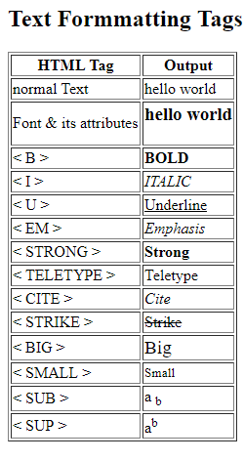

Sign:

Date:
PRACTICAL-2
Aim: Write HTML code to demonstrate the use of Anchor Tag for the
Following:
- Creating a web link that opens in new window.
- Creating a web link that opens in same window.
- Reference within the same HTML document.
- Reference to some image.
- Making an image a hyperlink to display second image.

Code:
<html>
<head>
<title>
My anchor
</title>
<body>
<a href="#" target="_parent" > Click this link to open in Current window </a>
<br>
<a href="#" target="_blank" > Click this link to open in new window </a>
<br>
<a href="anchorTag.html" target="_parent" > Reference within same html document </a>
<br>
<a href="ganpati.jpg" >Reference to some image </a>
<br>
<a href="Untitled.png"><img src="click.png" name="image2" > </a>
</body>
</html>

Output:
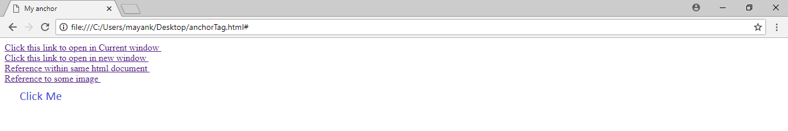

a.

b.
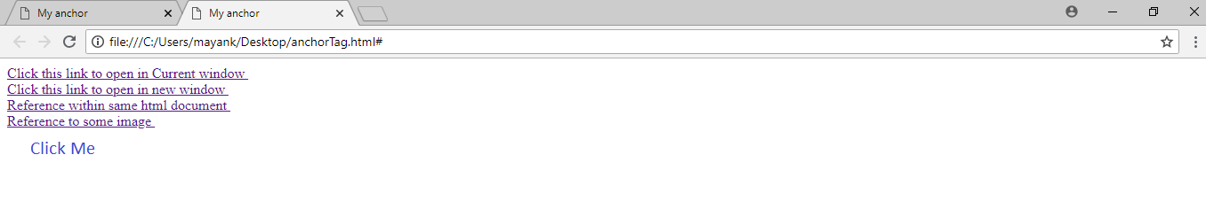
c.

d.

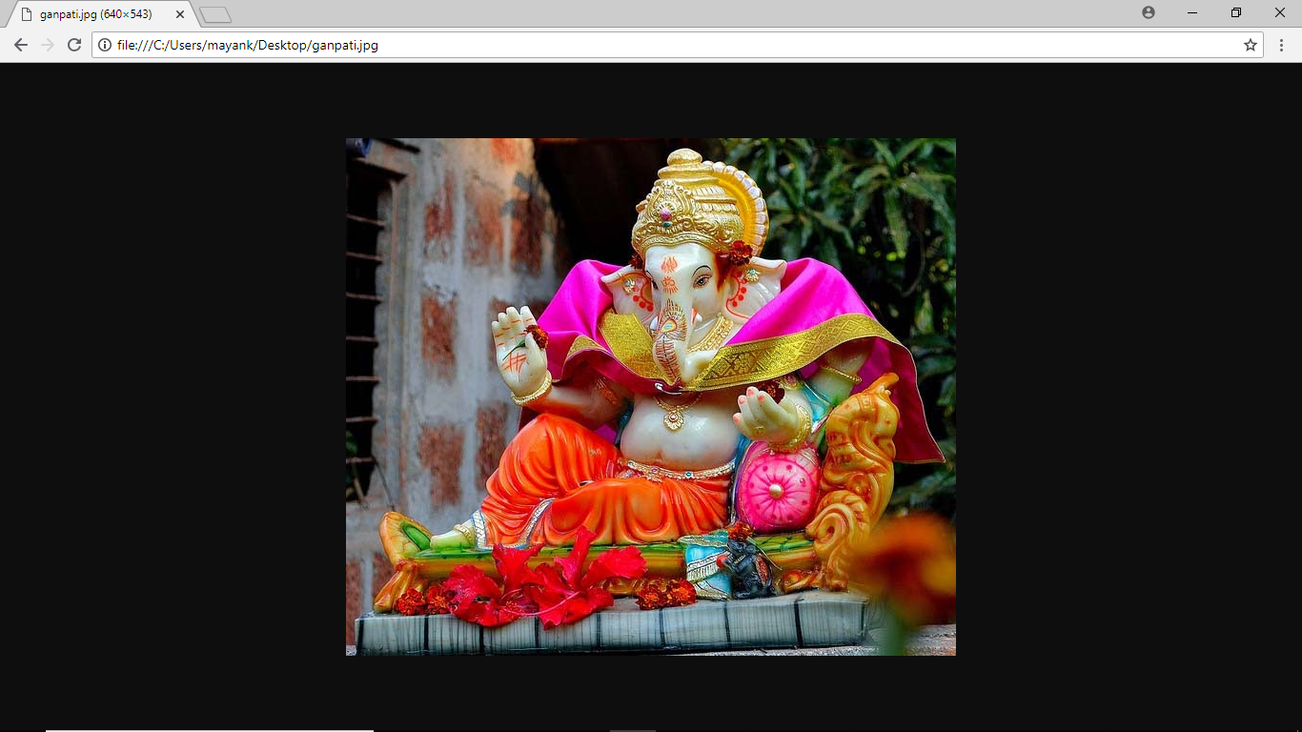

Sign:

Date:
PRACTICAL-3
Aim: Create your class timetable using tag.
Code:
<!DOCTYPE html>
<HTML>
<HEAD>
<TITLE>
Timetable
</TITLE>
</HEAD>
<BODY>
<B><TABLE BORDER='1' ALIGN="CENTER" STYLE="text-align: center;">
<TR><TD colspan='7' align="center"><H3>GOVERNMENT OF GUJARAT<BR>L.D. COLLEGE OF ENGINEERING,AHMEDABAD<BR>
CLASS TIMETABLE FOR SEM 6 IT-B EVEN TERM OF THE YEAR 2018_19<BR>
WEF-17-12-2018<BR>
ROOM NO-IT-103<BR>
</H3> </TD></TR>
<TR>
<TH>TIME</TH>

<TD><B>10:45</B></TD>
<TD><B>11:45</B></TD>
<TD><B>1:15</B></TD>
<TD><B>2:15</B></TD>
<TD><B>3:30</B></TD>
<TD><B>4:30</B></TD>

</TR>
<TR>
<TH>DAY</TH>
<TD><B>11:45</B></TD>
<TD><B>12:45</B></TD>
<TD><B>2:15</B></TD>
<TD><B>3:15</B></TD>
<TD><B>4:30</B></TD>
<TD><B>5:30</B></TD>
</TR >
<TR>
<TH ROWSPAN="4">MON </TH>
<TD ROWSPAN="4" COLSPAN="2" >AJ<BR>JTP<BR>102</TD>
<TD COLSPAN="2" >DCDR-B1-HMD(LAB1)</TD>
<TD ROWSPAN="4" >DCDR<BR>HMD<BR>103</TD>
<TD ROWSPAN="4" >SE<BR>NPD<BR>201</TD>

</TR>
<TR><TD COLSPAN="2">DCDR-B2-PRP(LAB2)</TD>
</TR><TR><TD COLSPAN="2">DCDR-B3-ME_NILESH(LAB3)</TD>
</TR><TR><TD COLSPAN="2">DCDR-B4-ME_ASHIKA(LAB3)</TD>
</TR>
<TR>
<TH ROWSPAN="4">TUES </TH>
<TD ROWSPAN="4" COLSPAN="2" >DE I<BR>MCP<BR>101</TD>
<TD COLSPAN="2" >DE I-B1-MCP(LAB5)</TD>
<TD ROWSPAN="4" >DCDR<BR>HMD<BR>103</TD>
<TD ROWSPAN="4" >SE<BR>JBC<BR>201</TD>
</TR>
<TR><TD COLSPAN="2">DE I-B2-ME_Sangeeta(LAB5)</TD>
</TR><TR><TD COLSPAN="2">DE I-B3-ME_Nirav(LAB6)</TD>
</TR><TR><TD COLSPAN="2">DE I-B4-ME_Shreya(LAB6)</TD>
</TR>
<TR>
<TH ROWSPAN="4">WED </TH>
<TD ROWSPAN="4" COLSPAN="2" >WT<BR>SJP<BR>101</TD>
<TD COLSPAN="2" >SE-B1-MCP(LAB4)</TD>
<TD ROWSPAN="4" >SE<BR>NPD<BR>103</TD>
<TD ROWSPAN="4" >-</TD>

</TR>
<TR><TD COLSPAN="2">SE-B2-JBC(LAB4)</TD>

</TR><TR><TD COLSPAN="2">SE-B3-NPD(LAB6)</TD>
</TR><TR><TD COLSPAN="2">SE-B4-ME_Shrenik(LAB6)</TD>
</TR>
<TR>
<TH ROWSPAN="4">THURS </TH>
<TD ROWSPAN="4" COLSPAN="2" >DE I<BR>MCP<BR>101</TD>
<TD COLSPAN="2" >WT-B1-SJP(LAB4)</TD>
<TD ROWSPAN="4" >WT<BR>SJP<BR>102</TD>
<TD ROWSPAN="4" >DCDR<BR>PRP<BR>103</TD>
</TR>
<TR><TD COLSPAN="2">WT-B2-MNP(LAB5)</TD>
</TR><TR><TD COLSPAN="2">WT-B3-PNR(LAB3)</TD>
</TR><TR><TD COLSPAN="2">WT-B4-ME_Trupti(LAB3)</TD>
</TR>
<TR>
<TH ROWSPAN="4">FRI </TH>
<TD ROWSPAN="4" COLSPAN="2" >AJ<BR>BBP<BR>101</TD>
<TD COLSPAN="2" >AJ-B1-BBP(LAB3)</TD>
<TD ROWSPAN="4" >SE<BR>JBC<BR>102</TD>
<TD ROWSPAN="4" >-</TD>
</TR>
<TR><TD COLSPAN="2">AJ-B2-JTP(LAB3)</TD>
</TR><TR><TD COLSPAN="2">AJ-B3-ME_Hiral(LAB2)</TD>
</TR><TR><TD COLSPAN="2">AJ-B4-ME_Arpita(LAB2)</TD>

</TR>
<TR>
<TH ROWSPAN="4">SAT </TH>
<TD COLSPAN="7" >DE-2B-B1-MNP(LAB7)</TD>
</TR>
<TR><TD COLSPAN="7" >DE-2B-B2-AJP(LAB7)</TD>
</TR>
<TR><TD COLSPAN="7" >DE-2B-B3-PRP(LAB7)</TD>
</TR>
<TR><TD COLSPAN="7" >DE-2B-B4-PNR(LAB6)</TD>
</TR >
</TABLE> </B>
</BODY>
</HTML>

Output:
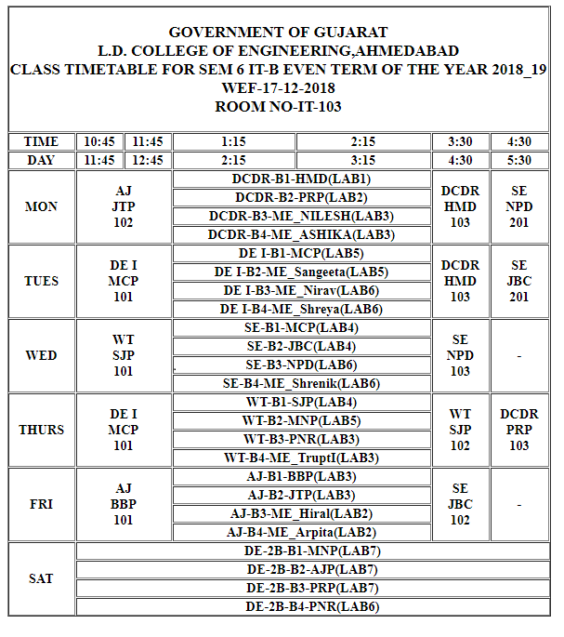

Sign:

Date:
PRACTICAL-4
Aim: Create a website in which all the hyperlinks are the list of an unordered list. you have to place this list in a frame that lies in left side of your homepage and after clicking any hyperlink the corresponding details should be displayed in a frame lying in right side of your web page.
Code:
Frame1(left frame):
<!DOCTYPE html>
<html>
<head>
<title>Practical-4</title>
</head>
<body>
<ul>
<li><a href="timetable.html" target="left">Timetabel</li>
<li><a href="webpagetable.html" target="left">Html Tags</li>
</ul>
</body>
</html>

Main page:
<!DOCTYPE html>
<html>
<head>
<title>Practical-4</title>
</head>
<body>
<frameset cols="50%,50%">

<iframe name="right" width="20%" height="700" src="frame1.html" ></iframe>
<iframe name="left" width="70%" height="700"src="webpagetable.html"></iframe>

</frameset>
</body>
</html>

Output:

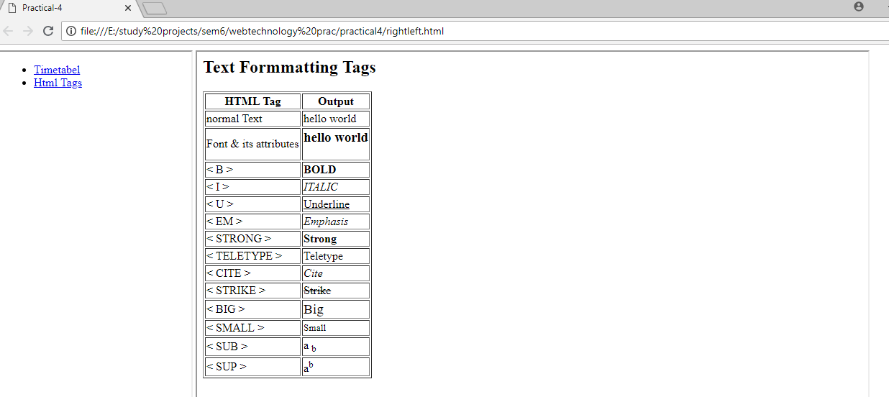

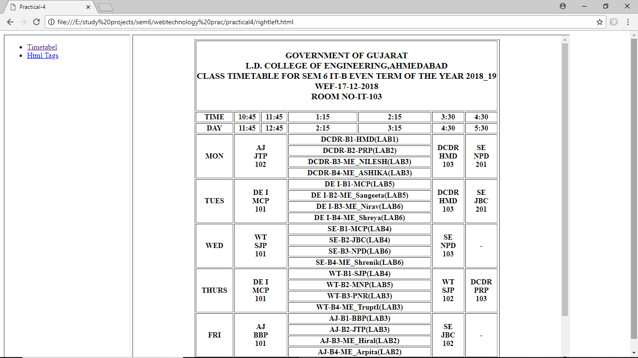

Sign:

Date:
PRACTICAL-5
Aim: Create webpage using list tags of HTML.
Code:
<!DOCTYPE html>
<html>
<head>
<title>practical 5</title>
</head>
<body>
<h1>HTML LIST:UNORDERED,ORDERED & DESCRIPTION LIST</h1>
<hr>
<h3>there are three types of HTML List</h3>
<ol>
<li>ORDERED </li>
<li>UNORDERED</li>
<li>DESCRIPTION</li>
</ol><hr>
<dl>
<dt><strong>ORDERED </strong>
<dd>the order in which items are presented is important.
<dt><strong>UNORDERED </strong>
<dd>An unordered list is simply a list of related items whose order does not matter.
<dt>< strong >DESCRIPTION</ strong>
<dd>Description lists are used to outline multiple terms and their descriptions, as in a glossary, for example.
</dl><hr>
<h3>UNORDERED LIST</h3>
<ul>
<li>ORDERED</li>
<li>UNORDERED</li>
<li>DESCRIPTION</li>
</ul><hr>
</body>
</html>
Output:
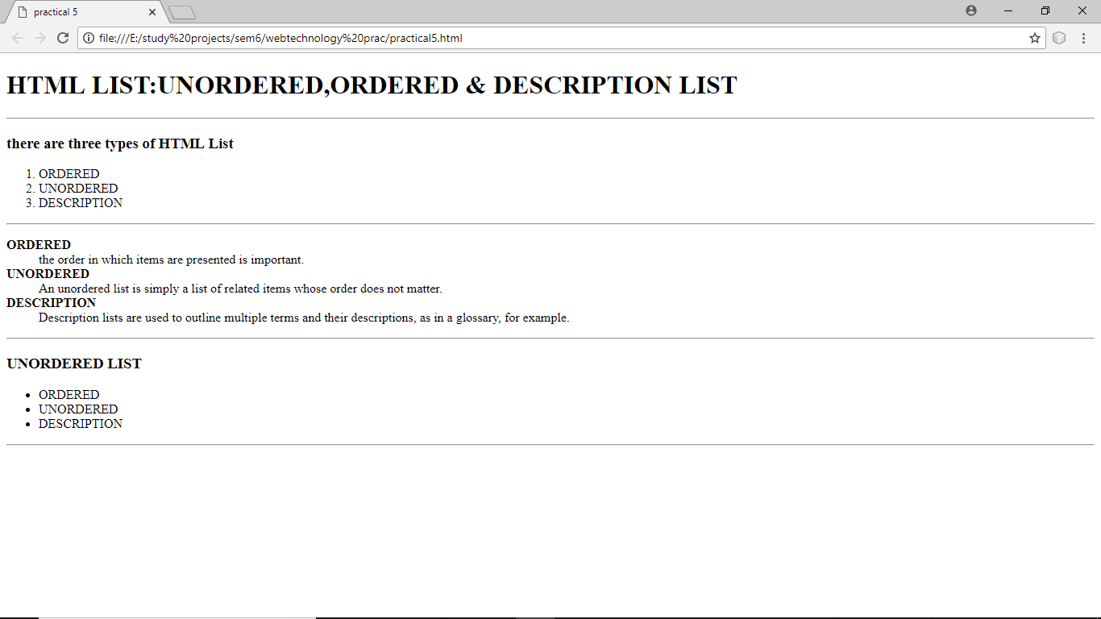

Sign:

Date:
PRACTICAL-6
Aim: Create employee registration webpage using HTML form objects.
Code:
<!DOCTYPE html>
<html>
<head>
<title>Register Form</title>
<meta name="viewport" content="width=device-width, initial-scale=1">
<style>
body {
font-family: Arial, Helvetica, sans-serif;
background-color: black;
}

* {
box-sizing: border-box;
}
.container {
padding:16px;
background-color: white;
}

input[type=text], input[type=password],input[type=tel] {
width: 100%;
padding: 16px;
margin: 5px 0 22px 0;
display: inline;
border: none;
background: #f1f1f1;
}
input[type=text]:focus, input[type=password]:focus,input[type=tel]:focus {
background-color: #ddd;
outline: none;
}
hr {
border: 1px solid #f1f1f1;
margin-bottom: 25px;
}
.registerbtn {
background-color: #4CAF50;
color: white;
padding: 16px 20px;
margin: 8px 0;
border: none;
cursor: pointer;
width: 100%;
opacity: 0.9;
}
.registerbtn:hover {
opacity: 1;
}
a {
color: dodgerblue;
}
.signin {
background-color: #f1f1f1;
text-align: center;
}
</style>
</head>
<body>
<form action="">
<div class="container">
<h1>Employee Registration Form</h1>
<p>Please fill in this form to create an account.</p>
<hr>
<input type="Radio" name="a" checked="checked"/>Mr.
<input type="Radio" name="a" />Mrs.
<input type="Radio" name="a" />Ms.
<br><br>
<input type="text" placeholder="Enter Full name" name="fullname" required> <input type="text" placeholder="Enter Email" name="email" required>
<input type="text" placeholder="Enter city name" name="city" required>
<label for="state"><b>State:</b></label>
<select name="state: ">
<option value="Gujrat">Gujrat</option>
<option value="Rajsthan">Rajsthan</option>
<option value="Goa">Goa</option>
</select>
<br>
<br>
<span> Upload Photo:</span>
<input type="file" name="photo" accept="image/*"/>
<br>
<input type="tel" placeholder="Enter Phonenumber" name="num" pattern="^\d{10}$" required>
<br>
<input type="password" placeholder="Enter Password" name="psw" required>
<hr>
<p>By creating an account you agree to our <a href="#">Terms & Privacy</a>.</p>
<button type="submit" class="registerbtn">Register</button>
</div>
<div class="container signin">
<p>Already have an account? <a href="#">Sign in</a>.</p>
</div>
</form>
</body>
</html>
Output:

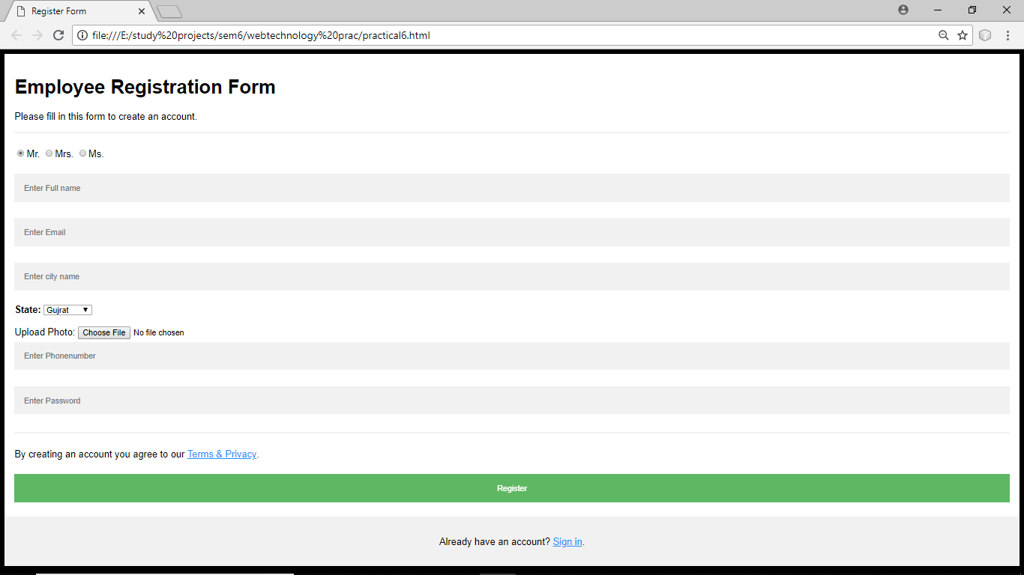

Sign:

Date:

PRACTICAL – 7

Aim: Design a web page of your home town with an attractive background color, text color , an image , font , etc.(use internal CSS )

Code:

<!DOCTYPE html>
<html>
<head>
<title>WT6</title>
<style>
body {
background-color:green;
}
h1{
color: red;
text-align:center;
}
p{
margin-top: 30px;
text-transform:capitalize;
font-size:50px;
}
h3{
text-transform:uppercase;
font-size:20px;
color:cyan;
}

img{
float:right;
height:500px;
width:400px;
margin-bottom: 600px;
<!--align: right;-->

}

</style>
</head>
<body >
<h1>Surendranagar – GJ13</h1>
<img src="Gujarat_Surendenagar_district.png">

<h3> Surendranagar is an administrative district in Saurashtra region of Gujarat state in India. It has a population of approximately 1.7 million people. Surendranagar city, along with the twin city of Wadhwan, has a total of 400,000 inhabitants, and is known as "Camp"</h3>
</body>
</html>

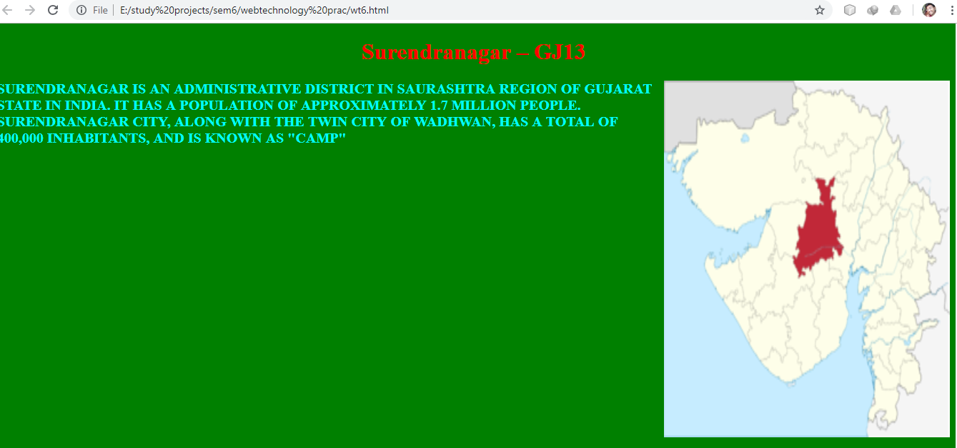

Date:

PRACTICAL – 8

Aim: Use inline CSS to format your resume.

Code:
<html>
<head >
<title >WT8</title>
</head>
<body style="background-color:rgb(150,150,150)">
<h1><center><u>RESUME</u></center></h1>
<hr>
<h2><u>Contact at:</u></h2>
<div>
<font size="3"><b>Mayank P. Timbal<br>9924038319<br>
mayankttimbal67@gmail.com</b> </font>
</div>
<h2><u>Personal Details:</u></h2>
<div>
<font size="3"> <strong>Date of Birth :</strong> <cite>March 29, 1999</cite><br>
<strong>Address</strong> : <cite>"Matru Krupa", Near Primary School,
Ratanpar.</cite><br>
<strong>Gender</strong> :<cite> Male</cite><br>
<strong>Marital Status</strong> : <cite>Unmarried</cite> <br>
<strong>Languages known</strong> : <cite>English, Hindi, Gujarati</cite> <br>
<strong>Hobbies</strong> :<cite> Reading,Writing,Travelling</cite></font>
</div>
<h2><u>Education Details:</u></h2>
<teletype>
<font size="3">
<table border="2">
<tr>
<th> sr. no &nbsp</th>
<th> qualification&nbsp </th>
<th> board/university&nbsp&nbsp </th>
<th> passing year&nbsp </th>
<th> percentage&nbsp </th>
</tr>
<tr>
<td>&nbsp 1 </td>
<td>&nbspS.S.C </td>
<td>&nbspG.S.E.B </td>
<td>&nbsp2014 </td>
<td>&nbsp 93% </td>
</tr>
<tr>
<td>&nbsp 2 </td>
<td>&nbspH.S.C </td>
<td>&nbspG.S.H.E.B </td>
<td>&nbsp2016</td>
<td>&nbsp 95% </td>
</tr>
<tr>
<td>&nbsp 3 </td>
<td> &nbspB.E </td>
<td>&nbspGTU </td>
<td> &nbsp2020 </td>
<td>&nbsp - </td>
</tr>
</table>
</font>
</teletype>
</body>
</html>
Output:

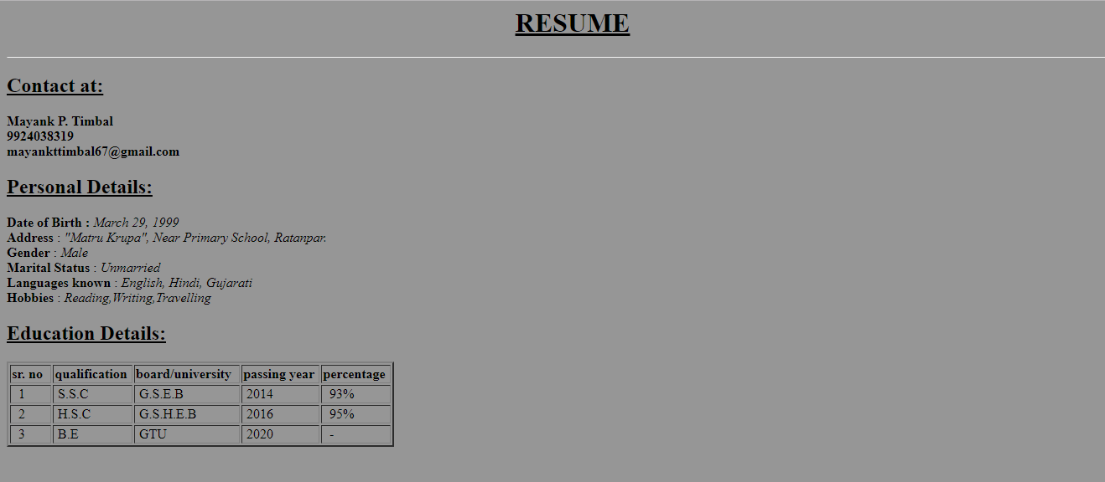

Sign:

Date:
PRACTICAL-9

Aim: Use External CSS to format class time table
Source code:
<html>
<head>
<link rel="stylesheet" type="text/css" href="timetable.css"/><title>practical8</title></head>
<body>
<table align="center" border="3px">
<tr><td><b>TIME<b></td><td><b>10:45<b></td><td><b>11:45<b></td><td><b>1:15<b></td><td><b>2:15<b></td><td><b>3:30<b></td>
<td><b>4:30<b></td></tr>
<tr><td><b>DAY<b></td><td><b>11:45<b></td><td><b>12:45<b></td><td><b>2:15<b></td><td><b>3:15<b></td><td><b>4:30<b></td>
<td><b>5:30<b></td></tr>
<tr><td><b>Mon<b></td><td>AJ<br>JTP</td><td>AJ<br>JTP</td>
<td colspan="2">
<div style="border:1px solid black">DCDR-B1-HMD(Lab 1)</div>
<div style="border:1px solid black">DCDR-B2-PRP(Lab 2)</div>
<div style="border:1px solid black">DCDR-B3-ME(Lab 3)</div>
<div style="border:1px solid black">DCDR-B4-ME(Lab 3)</div>
</td><td>DCDR<br>HMD</td><td>SE<br>NPD</td></tr>
<tr><td><b>TUE<b></td><td>IP<br>MCP</td><td>IP<br>MCP</td>
<td colspan="2">
<div style="border:1px solid black">IP-B1-MCP(Lab 5)</div>
<div style="border:1px solid black">IP-B2-ME(Lab 5)</div>
<div style="border:1px solid black">IP-B3-ME(Lab 6)</div>
<div style="border:1px solid black">IP-B4-ME(Lab 6)</div>
</td><td>DCDR<br>HMD</td><td>SE<br>JBC</td></tr>
<tr><td><b>WED<b></td><td>WT<br>SJP</td><td>WT<br>SJP</td>
<td colspan="2">
<div style="border:1px solid black">SE-B1-MCP(Lab 4)</div>
<div style="border:1px solid black">SE-B2-JBC(Lab 4)</div>
<div style="border:1px solid black">SE-B3-NPD(Lab 6)</div>
<div style="border:1px solid black">SE-B4-ME(Lab 6)</div>
</td><td>SE<br>NPD</td><td>-</td></tr>
<tr><td><b>THURS<b></td><td>IP<br>MCP</td><td>IP<br>MCP</td>
<td colspan="2">
<div style="border:1px solid black">WT-B1-SJP(Lab 4)</div>
<div style="border:1px solid black">WT-B2-MNP(Lab 5)</div>
<div style="border:1px solid black">WT-B3-PNR(Lab 3)</div>
<div style="border:1px solid black">WT-B4-ME(Lab 3)</div>
</td><td>DCDR<br>HMD</td><td>SE<br>JBC</td></tr>
<tr><td><b>FRI<b></td><td>AJ<br>BBP</td><td>AJ<br>BBP</td>
<td colspan="2">
<div style="border:1px solid black">AJ-B1-BBP(Lab 3)</div>
<div style="border:1px solid black">AJ-B2-JTP(Lab 4)</div>
<div style="border:1px solid black">AJ-B3-ME(Lab 2)</div>
<div style="border:1px solid black">AJ-B4-ME(Lab 2)</div>
</td><td>DCDR<br>HMD</td><td>SE<br>JBC</td></tr>
<tr><td>SAT</td>
<td colspan="6">
<div stye="border:1px solid black">DE_2B-B1-MNP(Lab 5)</div>
<div stye="border:1px solid black">DE_2B-B2-AJP(Lab 5)</div>
<div stye="border:1px solid black">DE_2B-B3-PRP(Lab 6)</div>
<div stye="border:1px solid black">DE_2B-B1-PNR(Lab 6)</div></td>
</tr>
</table>
</body>
</html>

CSS file:

td{
background-color:yellow;
color:black;
}

Output:
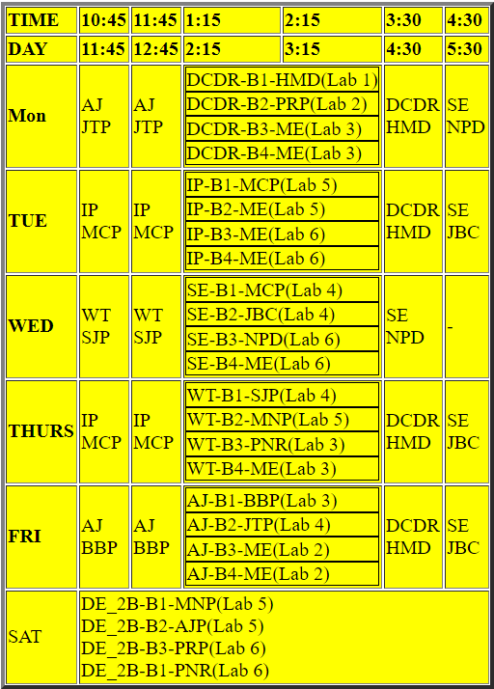

Sign:
Date:
PRACTICAL-10

Aim: Use External CSS to format class time table
Source code:
<!DOCTYPE html>
<html>
<head>
<title></title>
</head>
<body bgcolor="gray" >
<h1 align="center">LD College Of Engineering</h1>
<hr>
<h2>Welocome To LDCE</h2>
<hr><img src="logo.jpg" width="200" height="200">
<div>Lalbhai Dalpatbhai College of Engineering endearingly known as L.D.C.E is Ahmedabad’s premier engineering college situated at city’s heart surrounded by elite organization Like PRL, ATIRA, ISRO, IIM and CEPT. Started in 1948 with an aim of imparting quality higher education in various fields of engineering, it has seen unprecedented growth.
It is affiliated with Gujarat Technological University & administrated by states Department of Technical Education. </div>
<br>
<br>
<hr>
<h2>Images:</h2>
<img src="l-d-college-of-engineering-10.jpg" width="650" height="600">
<img src="l-d-engineering-college-navrangpura-ahmedabad-engineering-colleges-1gqqhnx.jpg" width="650" height="600">
</body>
</html>

Output:
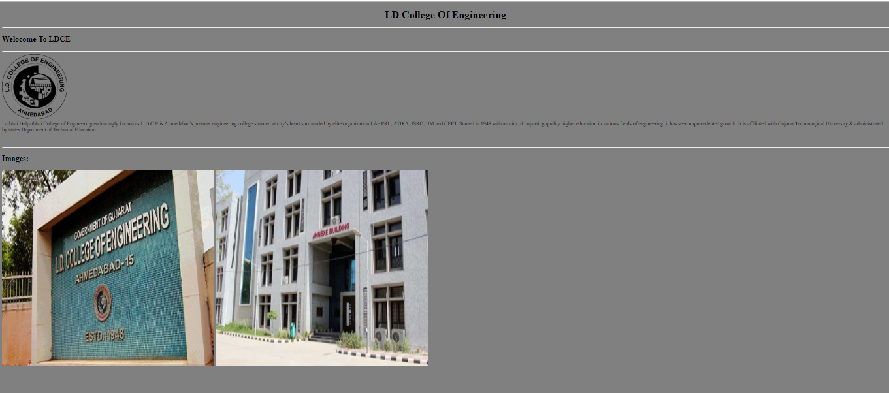

Sign:

Date:
PRACTICAL-11
Aim: Devlope a javascript to display today’s date
Source code:
<html>
<head></head>
<body>
<script type="text/javascript">
var a=new Date();
document.write("The date is:"+a.toString()+"<br>");
document.write("Today date is:"+a.getDate()+"<br>");
</script>
</body>
</html>

Output:
The date is : Wed Mar 27 2019 13:28:56 GMT+0530 (India Standard Time)
Today date is:27

Sign:

Date:
PRACTICAL-12

Aim: Devlope a simple calculator using java script

Source code:

<!DOCTYPE html>
<html>
<head>
<script type="text/javascript" src="calculator.js"></script>
<link rel="stylesheet" href="style.css" />
</head>
<body>
<form class="calcForm" name="calculator">
<input type="text" class="calcDisplay" id="display" />
<div class="calcRow">
<input type="button" class="calcButton" value="7" onclick="numInput('7')" />
<input type="button" class="calcButton" value="8" onclick="numInput('8')" />
<input type="button" class="calcButton" value="9" onclick="numInput('9')" />
<input type="button" class="calcButton" value="+" onclick="setOperation('add')" />
</div>
<div class="calcRow">
<input type="button" class="calcButton" value="4" onclick="numInput('4')" />
<input type="button" class="calcButton" value="5" onclick="numInput('5')" />
<input type="button" class="calcButton" value="6" onclick="numInput('6')" />
<input type="button" class="calcButton" value="-" onclick="setOperation('subtract')" />
</div>
<div class="calcRow">
<input type="button" class="calcButton" value="1" onclick="numInput('1')" />
<input type="button" class="calcButton" value="2" onclick="numInput('2')" />
<input type="button" class="calcButton" value="3" onclick="numInput('3')" />
<input type="button" class="calcButton" value="x" onclick="setOperation('multiply')" />
</div>
<div class="calcRow">
<input type="button" class="calcButton" value="0" onclick="numInput('0')" />
<input type="button" class="calcButton" value="." onclick="insertDecimal('.')" />
<input type="button" class="calcButton" value="C" onclick="clearDisplay()" />
<input type="button" class="calcButton" value="=" onclick="calculate()" />
</div>
</form>

Output:

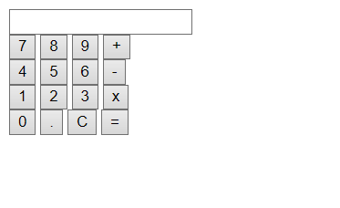

Sign:

Date:
PRACTICAL-13

Aim: Program for alert , confirm and prompt box
Source code:
<html>
<head></head>
<body>
<p>Experiment with popup boxes</p>
<script type="text/javascript">
if(confirm("do you agree?"))
alert("you have agreed");
else
input_text=prompt("Enter some String:","");
alert("Hi",+input_text);
</script>
</body>
</html>

Output:
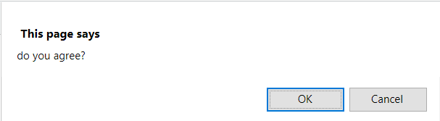

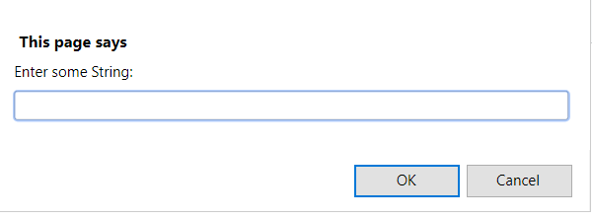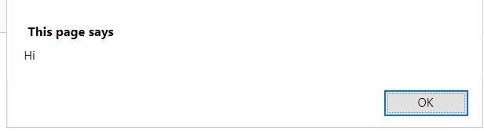

Sign:

Date:
PRACTICAL-14

Aim: Display information which are entered in from using Java Script.
Source code:
<html>
<head>
<script type="text/javascript">
function fun(){
document.getElementById('z').innerHTML= document.getElementById('u').value;
document.getElementById('y').innerHTML=document.getElementById('e').value;
document.getElementById('x').innerHTML= document.getElementById('m').value;
document.getElementById('w').innerHTML= document.getElementById('g').value;
document.getElementById('v').innerHTML= document.getElementById('f').value;
}
</script></head>
<body>

<form name="a">
<b>Name:</b><input type="text" name="uname" id="u"><br><br>
<b>Email:</b><input type="Email" name="mail" id="e"><br><br>
<b>Mobile no:</b><input type="text" name="mo" id="m"><br><br>
<b>Gender:</b><br><input type="radio" name="gen" value="male" id="g">Male<br>
<input type="radio" name="gen" value="female">Female<br>
<input type="radio" name="gen" value="other">Other<br><br>
<b>Favourite Colour:</b><select name="FC" id="f">
<option value="">Select</option>
<option value="White">White</option>
<option value="Black">Black</option>
<option value="Yellow">Yellow</option>
<option value="Red">Red
</option></select>
<br><br><input type="button" name="submit" value="submit" onclick="fun()"><br><br>
<b>Your Input:<b>
<p><span id='z'></span></p>
<p><span id='y'></span></p>
<p><span id='x'></span></p>
<p><span id='w'></span></p>
<p><span id='v'></span></p>
</form>
</body>
</html>

Output:
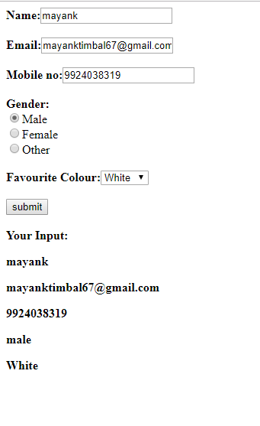
Sign:

Date:
PRACTICAL-15
Aim: Data Validate using Java Script.
Source code:
<html>
<head>
<script type="text/javascript">
function fun1(){
var x=document.forms["myForm"]["fname"].value;
var y=document.forms["myForm"]["pwd"].value;
if((x !=="mayank") && (y !=="1234")){
alert("Wrong Username or Password");
}else{
alert("login successfully");
}
}
</script>
</head>
<body>
<form name="myForm" onsubmit="return fun1()">
Username:<input type="text" name="fname"><br><br>
Password:<input type="Password" name="pwd"><br><br>
<input type="submit" value="submit">
</form>
</body>
</html>
Output:
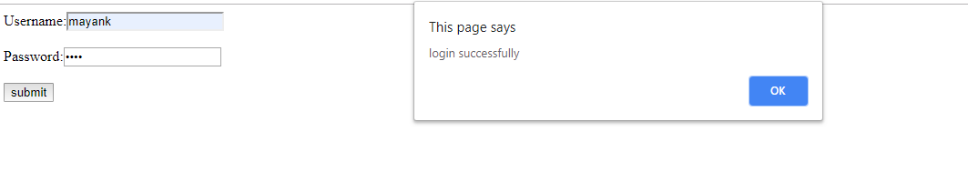
Sign:

Date:
PRACTICAL-16

Aim: Validation using Regular Expression
Source code:
<html>
<head>
<script type="text/javascript">
function validate(){
var x=document.getElementById('phone-number').value;
var y=/^[(]{0,1}[0-9]{3}[)]{0,1}[-\s\.]{0,1}[0-9]{3}[-\s\.]{0,1}[0-9]{4}$/;
var z=y.test(x);
alert("phone:"+z);
}
</script></head>
<body>
<form>
Enter phone number:<input type="text" id="phone-number" ><br><br>
<input type="submit" value="submit" onclick="validate()">
</form>
</body>
</html>

Output:
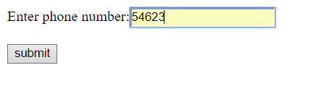
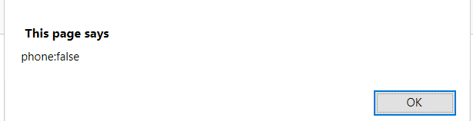

Sign:

Date:
PRACTICAL-17

Aim: Create XML file to store student information like Enrollment Number, Name, Mobile Number, Email Id.

Source code:
<?xml version = "1.0" encoding="UTF-8" standalone="yes"?>
<student>
<personal-details>
<enroll>160280116078</enroll>
<name>RamDesai</name>
</personal-details>
<contact-details>
<mobile-no>9999999999</mobile-no>
<email>ramdesai@gmail.com</email>
</contact-details>
</student>
<student>
<personal-details>
<enroll>160280116104</enroll>
<name>MayankTimbal</name>
</personal-details>
<contact-details>
<mobile-no>99999999999</mobile-no>
<email>mayanktim@gmail.com</email>
</contact-details>
</student>
?>

Date:
PRACTICAL-18

Aim: Create DTD for above (Practical no. 06).

Source code:

<!DOCTYPE employee
[
<!ELEMENT employee (name,address,contact-details,info)>
<!ELEMENT name(lastname,firstname)>
<!ELEMENTlastname (#PCDATA)>
<!ELEMENTfirstname (#PCDATA)>
<!ELEMENT address(mailaddress1,mailaddress2,city,state,zip)>
<!ELEMENT mailaddress1 (#PCDATA)>
<!ELEMENT mailaddress2 (#PCDATA)>
<!ELEMENT city (#PCDATA)>
<!ELEMENT state (#PCDATA)>
<!ELEMENT zip (#PCDATA)>
<!ELEMENT contact-details(mailaddress,mobile-no)>
<!ELEMENTmailaddress (#PCDATA)>
<!ELEMENT mobile-no (#PCDATA)>
<!ELEMENT info(language-known,additional-info)>
<!ELEMENT language-known (#PCDATA)>
<!ELEMENT additional-info (#PCDATA)>
]>

Date:
PRACTICAL-19

Aim: Create XML Schema for above (Practical no. 06).
Source code:
<?xml version = "1.0" encoding="UTF-8" standalone="yes"?>
<!DOCTYPE employee SYSTEM "practical18.dtd">
<employee>
<name>
<lastname>Desai</lastname>
<firstname>Ram</firstname>
</name>
<address>
<mailaddress1>Visnagar</mailaddress1>
<mailaddress2>Mahesana</mailaddress2>
<city>Mahesana</city>
<state>Gujarat</state>
<zip>384305</zip>
</address>
<contact-details>
<mailaddress>ramdesai1000@gmail.com</mailaddress>
<mobile-no>9662417153</mobile-no>
</contact-details>
<info>
<language-known>gujarati-english</language-known>
<additional-info>if any</additional-info>
</info>
</employee>
<employee>
<name>
<lastname>Timbal</lastname>
<firstname>Mayank</firstname>
</name>
<address>
<mailaddress1>Saraspur</mailaddress1>
<mailaddress2>Surendranagar</mailaddress2>
<city>Surendranagar</city>
<state>Gujarat</state>
<zip>382456</zip>
</address>
<contact-details>

<mailaddress>mayanktimbal67@gmail.com</mailaddress>
<mobile-no>9924038319</mobile-no>
</contact-details>
<info>

<language-known>gujarati-english</language-known>
<additional-info>if any</additional-info>
</info>
</employee>
?>

Date:
PRACTICAL-20

Aim: php program to display today’s date
Source code:
<html>
<body>
<?php
$today=date("d/m/Y");
echo "Today date is:".$today;
?>
</body>
</html>

Output:
Today date is:27/3/2019

Sign:

Date:
PRACTICAL-21
Aim: php program to check number is prime or not
Source code:
<html>
<head></head>
<body>
<form method="post">
Enter Number:<input type="text" name="input"><br><br>
<input type="submit" name="submit" value="submit">
</form>
<?php
if($_POST){
$input=$_POST['input'];
for($i=2;$i<=$input-1;$i++){
if($input%$i==0){
$value=True;
}
}
if(isset($value)&&$value){
echo 'The Number'.$input.'is not prime';
}else{
echo 'The Number'.$input.'is prime';
}
}
?>
</body>
</html>

Output:

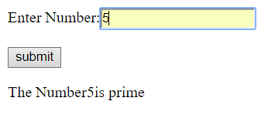

Sign:

Date:
PRACTICAL-22
Aim: Create HTML page that contain textbox, submit and reset button. Write php program to insert this information in database and display it.
Source code:
<html>
<head>
<title>
Practical 21
</title>
</head>
<body>
<form method="get" action="prac21.php">
Name:
<input type="text" name="name"/>
<br/>
<input type="submit" value="submit"/>
<input type="reset" value="reset"/>
<br/>
<a href="display.php">Display All Records</a>
</form>
</body>
</html>

prac_21.php:

<?php
$iname = $_GET['name'];
echo $iname;
$conn= new mysqli('localhost','root','','info');
if($conn->connect_error)
echo "connection failed";
else
{
$q="insert into information(name) VALUES ('".$iname."')";
if(!mysqli_query($conn,$q))
echo "Problem occured...";
else
echo "Record inserted successfully...";
echo "connection done";
}
mysqli_close($conn);
?>

display.php:

<html>
<body>
<table align="center">
<tr><th>Name</th></tr>
<?php
$conn= new mysqli('localhost','root','','info');
if($conn->connect_error)
echo "Connection failed";
else
{
$q="select * from information";
$result=mysqli_query($conn,$q);
while($row=mysqli_fetch_assoc($result))
{?>
<tr><td>
<?php echo $row['name'];?>
</td></tr>
<?php }
mysqli_close($conn);
}
?>
</table>
</body>
</html>

OUTPUT:
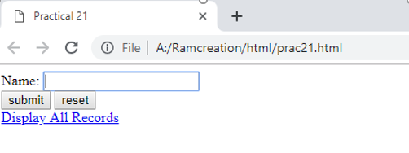

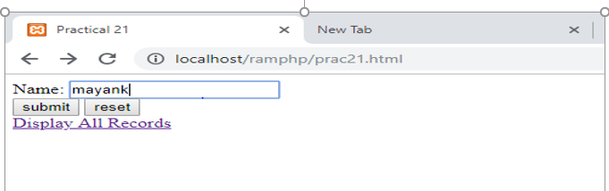

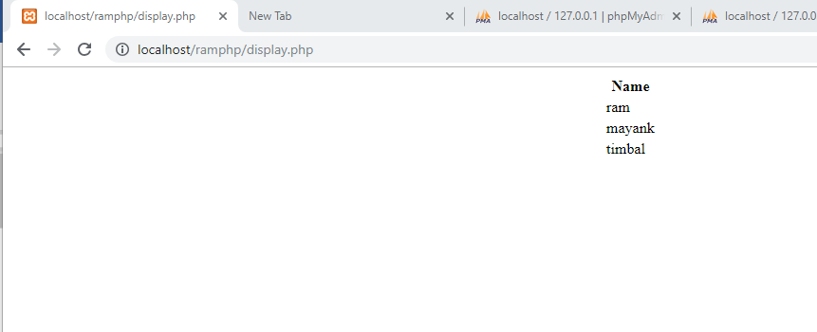
Sign:

